**IDEATION PHASE**

**PROBLEM STATEMENTS**

|  |  |
| --- | --- |
| Date | 20-09-2022 |
| Team ID | PNT2022TMID45345 |
| Project Name | Plasma Donor Application |
| Maximum Marks | 2 Marks |

**1,**

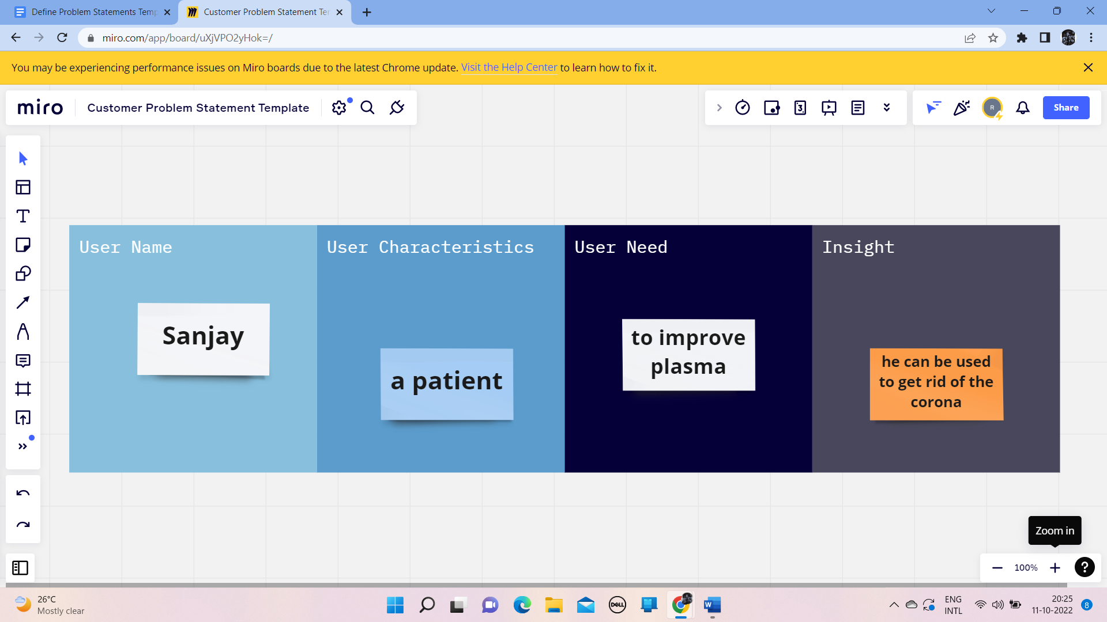

**2,**

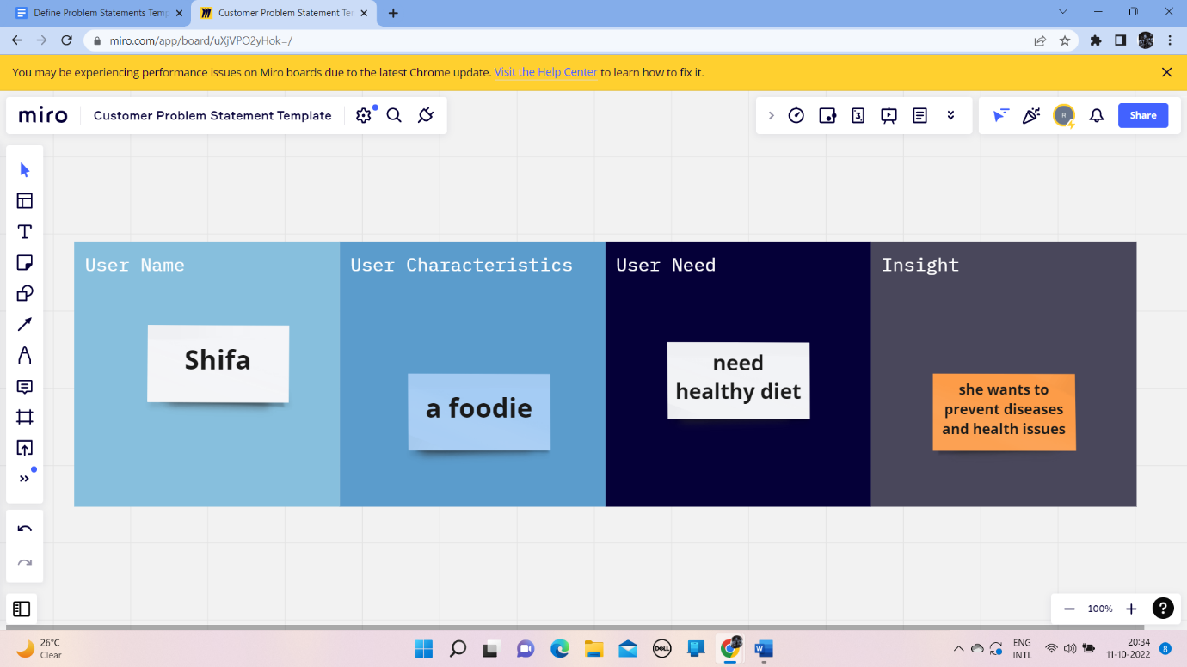

**3,**

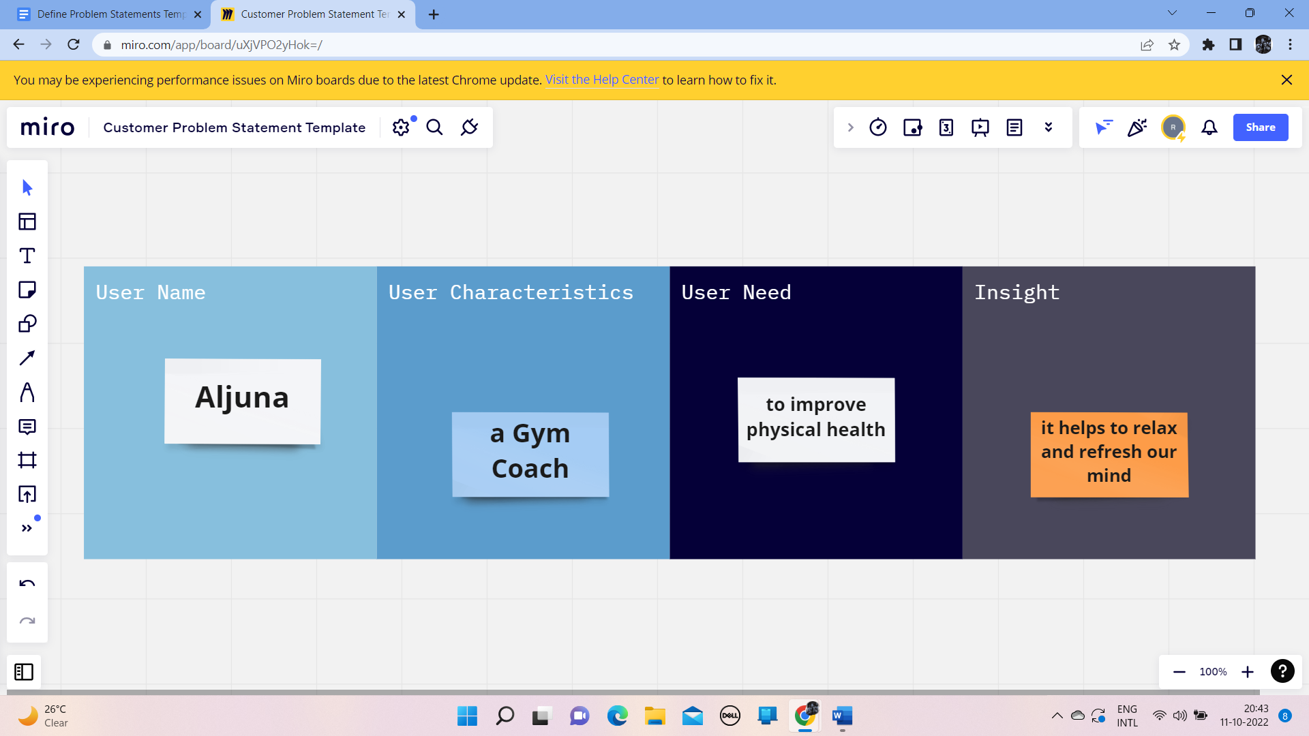

|  |  |  |  |  |
| --- | --- | --- | --- | --- |
| **Problem Statements** | **User Name** | **User Characteristics** | **User Need** | **Insight** |
| 4 | Karthik | Diabetes patient | need insulin | it controls the blood sugar level |
| 5 | Thiru | Heart patient | were hospitalized | he had not been diagnosed with cardiovascular issues |
| 6 | Aneer | A Manager | has been affected by Covid | he has high blood pressure |